UNIT - IV
Dimensionality Reduction
Linear Discriminant Analysis (LDA) Principal Component Analysis (PCA) Factor Analysis (FA)
Independent Component Analysis (ICA) Locally Linear Embedding (LLE) Isomap
Least Squares Optimization (LSO)
Evolutionary Learning Genetic algorithms Genetic Offspring Genetic Operators
Using Genetic Algorithms

DimensionalityReduction
Dimensionality reduction is the process of reducing the number of features (or dimensions) in a dataset while retaining as much information as possible. This can be done for a variety of reasons, such as to reduce the complexity of a model, to improve the performance of a learning algorithm, or to make it easier to visualize the data.
There are several techniques for dimensionality reduction, including principal component analysis (PCA), singular value decomposition (SVD), and linear-discriminant analysis (LDA). Each technique uses a different method to project the data onto a lower-dimensional space while preserving important information.
In machine learning, high-dimensional data refers to data with a large number of features or variables. The curse of dimensionality is a common problem in machine learning, where the performance of the model depreciates as the number of features increases. This is because the complexity of the model increases with the number of features, and it becomes more difficult to find a good solution. In addition, high-dimensional data can also lead to overfitting, where the model fits the training data too closely and does not generalize well to new data.
There are two main approaches to dimensionality reduction: Feature selection and

Feature extraction.
- FeatureSelection Feature selection involves selecting a subset of the original features that are most relevant to the problem at hand. The goal is to reduce the dimensionality of the dataset while retaining the most important features.
In feature selection, we are interested in finding k of the total of n features that give us the most information and we discard the other (n-k) dimensions.
There are several methods for feature selection, including filter methods, wrapper methods, and embedded methods. Filter methods rank the features based on their relevance to the target variable, wrapper methods use the model performance as the criteria for selecting features, and embedded methods combine feature selection with the model training process.

- Feature Extraction: Feature extraction involves creating new features by combining or transforming the original features. The goal is to create a set of features that captures the essence of the original data in a lower dimensional space.
In feature extraction, we are interested in finding a new set of k features that are the combination of the original n features.
There are several methods for feature extraction, including principal component analysis (PCA), linear discriminant analysis (LDA), and t-distributed stochastic neighbor embedding (t SNE).

Methods of Dimensionality Reduction
The various methods used for dimensionality reduction include:
  - Linear Discriminant Analysis(LDA)
  - Principal Component Analysis(PCA)

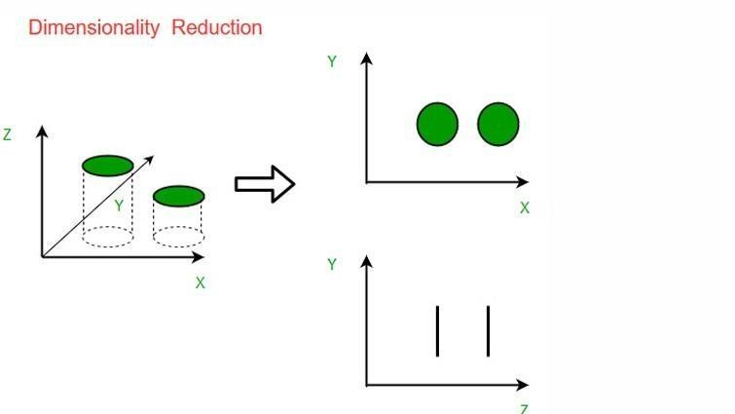

LinearDiscriminantAnalysis(LDA)
Linear Discriminant Analysis (LDA) is one of the commonly used dimensionality reduction techniques in machine learning to solve multi classification problems.
Dimensionality reduction is a technique used in machine learning to reduce the number of features (variables) in a dataset while preserving important information. It helps in improving efficiency, performance, and visualization of data.
LDA is also known as Normal Discriminant Analysis (NDA) or Discriminant Function Analysis (DFA).
LDA takes data with many features (high-dimensional data) and transforms it into data with fewer features (low-dimensional data) while preserving clear separation between classes in order to reduce resources and dimensional costs.
For example, if we have two classes with only one feature, separating them clearly can be difficult. Using just one feature may cause the classes to overlap.
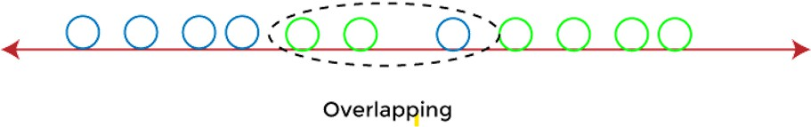
To overcome the overlapping issue in the classification process, we must increase the number of features regularly.

Example:
Suppose we have two sets of data points belonging to two different classes that we want to classify.
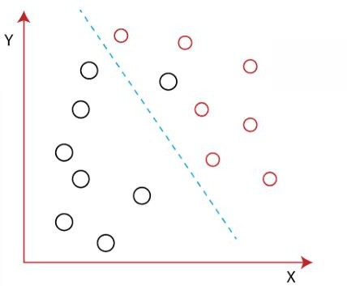
When the data points are plotted on the 2D plane, there's no straight line that can separate the two classes of the data points completely
Sometimes, it is not possible to separate data points clearly using a straight line in a 2-D space.

Using Linear Discriminant Analysis (LDA), we can reduce the 2-D data to 1-D in a way that keeps the classes well separated. This helps LDA maximize the separation between multiple classes.

How Linear Discriminant Analysis (LDA) works?
Linear Discriminant analysis is used as a dimensionality reduction technique in machine learning, using which we can easily transform a 2-D and 3-D graph into a 1-dimensional plane.
Example: - we have two classes in a 2-D plane having an X-Y axis, and we need to classify them efficiently. LDA uses both X and Y axis to create a new axis by separating them using a straight line and projecting data onto a new axis.
Hence, LDA maximize the separation between these classes and reduce the 2-D plane into 1-D
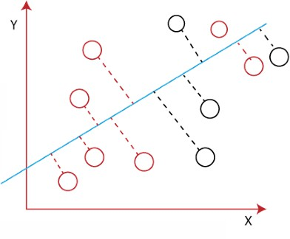
To create a new axis, Linear Discriminant Analysis uses the following criteria:
    - It maximizes the distance between means of two classes.
    - It minimizes the variance within the individual class.
Using the above two conditions, LDA generates a new axis in such a way that it can maximize the distance between the means of the two classes and minimizes the variation within each class.
In other words, we can say that the new axis will increase the separation between the data points of the two classes and plot them onto the new axis.

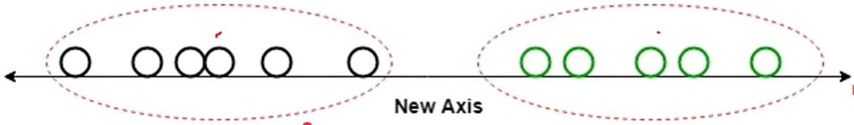

Why LDA?
- Logistic Regression works well for binary classification, but it is less effective for multi-class problems. LDA can handle multiple classes efficiently.
- LDA can also be used in data pre-processing to reduce the number of features
- LDA is also used in face detection algorithms. In Fisher faces, LDA is used to extract useful data from different faces.
Steps to implement LDA
Step1:-Compute the class means of dependent variable
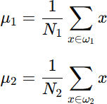

Step2:-Derive the Covariance matrix of the class variable
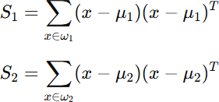
Step3:- Compute the within class Scatter matrix

Step4:- Compute the between class Scatter matrix

Step-5:-Compute the Eigen values and Eigen Vectors from the within class Scatter matrix and between class Scatter matrix

Step-6:- Sort the values of Eigen values and select to the top k Eigen vectors
Step-7:- Find the Eigen vectors corresponds to the top k Eigen vectors
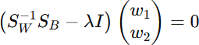
Step-8:- Obtain the LDA by taking the dot product of Eigen vectors and original data.
Drawbacks of Linear Discriminant Analysis (LDA)
LDA is mainly used for supervised classification with two or more classes, which logistic regression cannot handle effectively.
LDA can fail when different classes have the same mean. In such cases, LDA cannot find a new axis that separates the classes clearly using a straight line. To overcome such problems, we use non-linear Discriminant analysis in machine learning.

Extension to Linear Discriminant Analysis (LDA)
Linear Discriminant analysis is one of the most simple and effective methods to solve classification problems in machine learning. It has so many extensions and variations as follows:
- Quadratic Discriminant Analysis (QDA): Quadratic Discriminant Analysis (QDA) is an extension of Linear Discriminant Analysis (LDA). It allows each class to have its own covariance matrix.
- Flexible Discriminant Analysis (FDA): Flexible Discriminant Analysis (FDA) is an extension of Linear Discriminant Analysis (LDA) that allows for non-linear relationships between the predictor variables and the class labels.

Applications of LDA
Some of the common real-world applications of Linear Discriminant Analysis are given below:

Face Recognition:
Face recognition is the popular application of computer vision, where each face is represented as the combination of a number of pixel values. In this case, LDA is used to minimize the number of features to a manageable number before going through the classification process. It generates a new template in which each dimension consists of a linear combination of pixel values. If a linear combination is generated using Fisher's linear Discriminant, then it is called Fisher's face.

Medical:
In the medical field, LDA is used to classify diseases based on different patient health parameters and ongoing treatment. It categorizes the disease as mild, moderate, or severe, which helps doctors decide whether to increase or reduce the treatment intensity.

Customer Identification:
LDA is used in customer identification to find important features and group customers based on their characteristics. It helps identify which customers are more likely to buy a product in a shopping mall, making it easier to target the right group. LDA is also useful for prediction and decision-making, such as predicting whether a customer will buy a product or not. In machine learning and robotics, LDA is used for classification problems where it groups similar data based on features like pitch, frequency, sound, and tone, helping systems understand and respond more effectively.

Principal Component Analysis
This method was introduced by Karl Pearson. It works by converting data from a

higher-dimensional space to a lower-dimensional space.
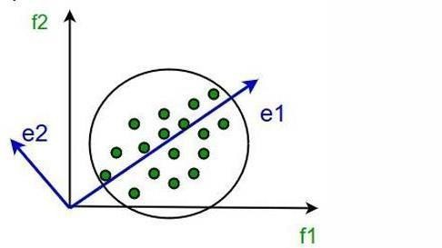
It involves the following steps:
- Construct the covariance matrix of the data.
- Compute the eigenvectors of the covariance matrix.
- Select the eigenvectors with the largest eigenvalues, because they keep most of the variance (important information) of the original data.

Step1. Data
Consider a dataset with n features (variables): X₁, X₂, …, Xₙ
Let there be N data examples (records)

For the i-th feature (Xᵢ), the values across the dataset are:

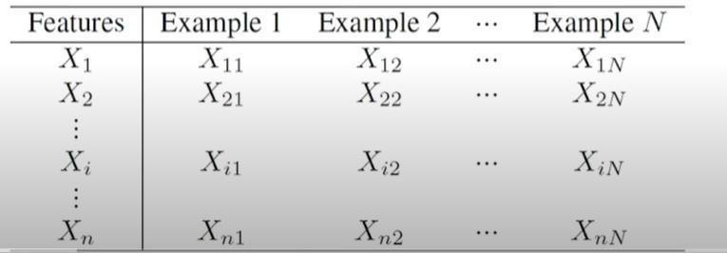

Step2: Compute the means of the variables.
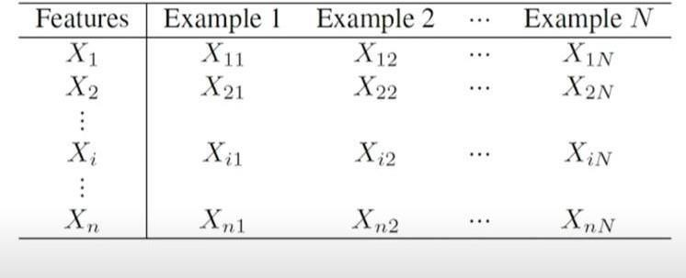
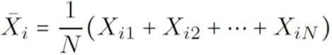

Step3: Calculate the covariance matrix
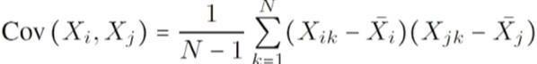

Step4: Calculate the eigenvalues and eigenvectors of the covariance matrix
`
  - Set up the equation: Form a polynomial equation using the covariance matrix S. This equation has degree n (for n variables). It gives n real roots, and these roots are the eigenvalues of S
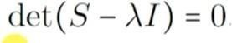
  - If λ (lambda) is an eigenvalue, then the corresponding eigenvector is a vector associated with that eigenvalue.
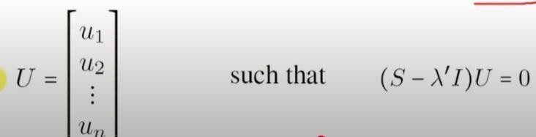

Step5: Calculate the eigenvalues and eigenvectors of the covariance matrix
Normalize the eigenvectors means making the length of each vector equal to 1.
If we have a vector X, we normalize it by dividing the vector by its length (norm).
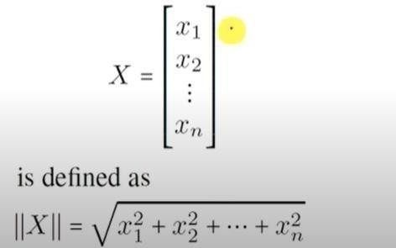

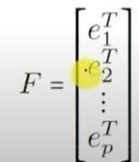

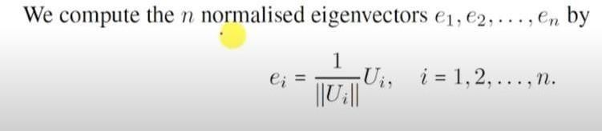

Step6:
Derive the new dataset
- Order the eigenvalues from highest to lowest.
- The unit eigenvector corresponding to the largest eigenvalues becomes the

first principal component.
- This principal component represents the direction with the maximum variance in the data.
Let the eigenvalues in descending order be:

λ₁ ≥ λ₂ ≥ … ≥ λₙ,
and let the corresponding unit eigenvectors be e₁, e₂, …, eₙ.
  - Choose a positive integer p such that 1 ≤ p ≤ n.
(This means selecting how many principal components you want.)

Choose the eigenvectors corresponding to the largest eigenvalues
λ₁, λ₂, …, λₚ and form a p × n matrix (write the eigenvectors as row vectors).
This matrix is called the feature vector matrix used to create the new reduced-dataset.

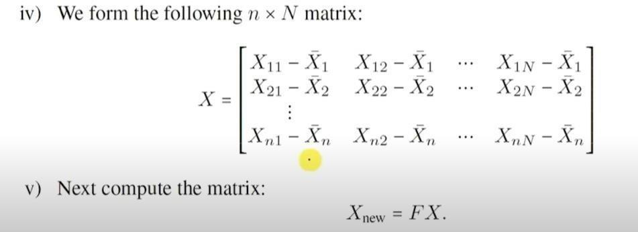
Note that this is a p×N matrix. This gives us a dataset of N samples having p features.

Advantages of PCA
- PCA reduces data size by compressing high-dimensional data into fewer principal components, so less storage space is required.
- PCA reduces computation time because machine learning algorithms work with fewer features.
- PCA removes redundant features by combining correlated variables into principal components.
- PCA improves data visualization by converting high-dimensional data into 2D or 3D principal components.
- PCA helps prevent overfitting by reducing the number of input variables in a model.
- PCA performs feature extraction by identifying the most important directions of variance in the data.
- PCA improves model performance by removing noise and irrelevant information from the dataset.

Disadvantages of PCA
- PCA may cause data loss because some information is discarded during dimensionality reduction.
- PCA mainly captures linear relationships, so it may not work well for nonlinear data.
- PCA may not represent all datasets well because mean and covariance alone may not describe complex data structures.
- PCA makes it difficult to decide how many principal components to keep in practice.
- PCA reduces interpretability because principal components are combinations of original variables.
- PCA is sensitive to outliers, which can affect the direction of principal components.

FactorAnalysis
Factor analysis is a statistical method used to simplify a large number of variables by grouping them into a smaller number of factors. These factors represent the common patterns or shared information among the original variables. This helps make the data easier to understand and use in other analyses.
In factor analysis, a factor is a hidden (unobserved) variable that explains the common pattern or relationship among a group of observed variables. These observed variables are measurable and directly collected in a study. The factor represents the shared information or common pattern behind those variables.
In factor analysis, a "factor" is something hidden that you can’t directly see or measure, but it affects several things you can measure.
The things you can measure are called observed variables (also called indicators).These are the questions or data points you collect in a survey or study.

Condense data means to make the data simpler and smaller by reducing the number of variables, without losing important meaning.
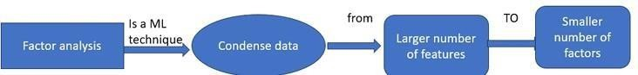

The general steps involved in conducting a factor analysis:

Check if Your Data is good for Factor Analysis:
Bartlett’s Test is used to check whether the variables are related to each other. If the result is significant (p-value < 0.05), it means the variables are sufficiently connected, and the data is suitable for factor analysis.
Bartlett’s Test answers the question: “Are the variables related enough to group them into factors?”

Kaiser-Meyer-Olkin(KMO)Measure:
This test checks whether your data is suitable for factor analysis. A KMO value above 0.6 means the data is good enough to proceed.
In simple terms, it answers: “Is my sample good for finding
patterns?”

Choosing the Extraction Method:
This step involves selecting how to find factors in the data. The two common methods are:

Principal Component Analysis(PCA):
PCA is used when the main goal is data reduction. It reduces the number of variables while keeping the most important information.
Example: If you have 10 health survey questions and want to reduce them to 2–3 summary scores, PCA is used.

Principal Axis Factoring (PAF):
PAF is used when the goal is to identify underlying factors. It finds hidden factors that explain patterns in the data.
Example: If you collect data on students’ feelings, sleep, focus, and motivation, and want to find hidden causes like stress or anxiety, PAF is used.

Steps of factor analysis process
- Factor extraction
Factor extraction is the process of finding hidden factors from the data.
First, we use a chosen extraction method like PCA or PAF to identify the initial factors, which represent the underlying patterns in the data.
Next, eigenvalues are used to decide how many factors to keep. The general rule is to keep factors with eigenvalues greater than 1, because they explain more useful information.

Example: If 5 factors are found but only 3 have eigenvalues greater than 1, we keep those 3 and remove the others.
Then, initial factor loadings are calculated. Factor loadings show how strongly each variable is related to a factor. A higher loading means a stronger relationship. Example: If “feeling tired” has a high loading on the “stress” factor, it means it is strongly related to stress.

Determine the Number of Factors to Retain
Scree Plot: Plot eigenvalues in descending order and look for the point where the curve becomes flat (elbow). This point shows how many factors to keep.
Eigenvalues: Keep the factors with eigenvalues greater than 1, as they contain important information.

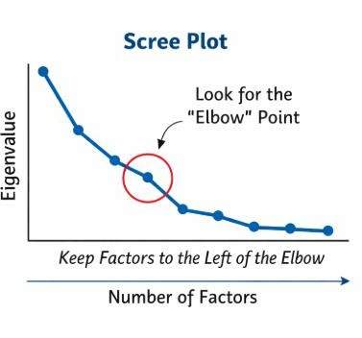

- Factor Rotation : Factor rotation is used to rearrange factors to make the results simpler and easier to understand. It helps clean up the factors so they can be clearly named and interpreted.

There are two types of rotation:
  - Orthogonal Rotation (Varimax, Quartimax): Assumes factors are uncorrelated (no relationship between factors).

  - Oblique Rotation (Promax, Oblimin): Allows factors to be correlated.
After rotation, we examine the factor loadings. Factor loadings indicate how strongly each variable is related to a factor. A high loading means a strong relationship, while a low loading means a weak relationship.

Interpret and Label the Factors
After rotation, analyze the factor loadings to understand the meaning of each factor. Then, assign meaningful names to the factors based on the variables that have high loadings on them.

Compute Factor Scores(if needed)
Calculate the factor scores for each individual to represent their value on each factor.

Report and Validate the Results
- Report the final factor structure, including factor loadings and communalities.
- Validate the results using additional data or by conducting a confirmatory factor analysis if necessary.
Factor loadings show how strongly each variable is related to a factor.
  - Example: In a “Health” factor, exercise might have a loading of 0.8 → strongly related.
Communalities show how much of each variable’s variation is explained by all factors combined.
Example: If sleep has a communality of 0.7 → 70% of sleep patterns are explained by the factors.

Types of Factor Analysis
There are two types of Factor Analysis used in datascience:

Exploratory Factor Analysis (EFA)
Exploratory Factor Analysis (EFA) is a statistical method used to identify hidden patterns or groups in a set of data. It helps to understand how different variables (such as survey questions) are related to each other without making prior assumptions.

  - Researchers do not make any a priori assumptions about the relationships among factors, allowing the data to reveal the structure naturally.
  - EFA helps in identifying the number of factors required to explain the variance in the observed variables.
  - It also helps in understanding the relationship between variables and the underlying factors.

Confirmatory Factor Analysis(CFA)
Confirmatory Factor Analysis (CFA) is a statistical method used to test whether the data fits a predefined structure or model. It is used when the researcher already has a theory about how variables are grouped into factors.
  - In CFA, the researcher decides in advance which variables belong to which factors.
  - It uses Structural Equation Modeling (SEM) to check whether the data supports this assumed structure.
  - CFA evaluates how well the observed variables match the expected factor structure.
  - It also considers measurement errors and analyzes relationships between observed variables and hidden factors.
  - The hypothesized model is tested using real data to check its validity.
CFA is used to confirm whether your idea or model about data grouping is correct, instead of discovering it.

Types of Factor Extraction Methods
Some of the types of factor extraction methods are discussed below:

Principal Component Analysis (PCA):
  - PCA is a common method used to find hidden patterns (factors) in data. It looks for factors that explain the most variation in your data first.

  - Factor weights are computed, and it keeps extracting new factors one by one until there is no more important information left.
  - After extraction, the factor model is often rotated for further analysis to enhance interpretability.

Canonical Factor Analysis:
- CFA is Also known as Rao’s Canonical Factoring, this method is similar to Principal Component Analysis (PCA) but uses the principal axis method.
- It simplifies complex data by identifying underlying patterns or factors.
- Unlike PCA, it focuses on shared variance among variables, meaning it finds common patterns that multiple variables have in common.
- It aims to uncover the common underlying factors that influence the observed data.
- It finds factors that have the highest canonical correlation with observed variables.
(Canonical correlation means relationships between sets of variables.)
- Canonical Factor Analysis is not affected by data rescaling, making it robust.
(Data rescaling means adjusting data values to a different scale.)

Common Factor Analysis:
- Common Factor Analysis (CFA), also known as Principal Factor Analysis (PFA) or Principal Axis Factoring (PAF), is a statistical method used to identify the underlying relationships between measured variables.
- Unlike Principal Component Analysis (PCA), this considers all variance in the data, CFA focuses specifically on the shared variance—the variance that is common among variables

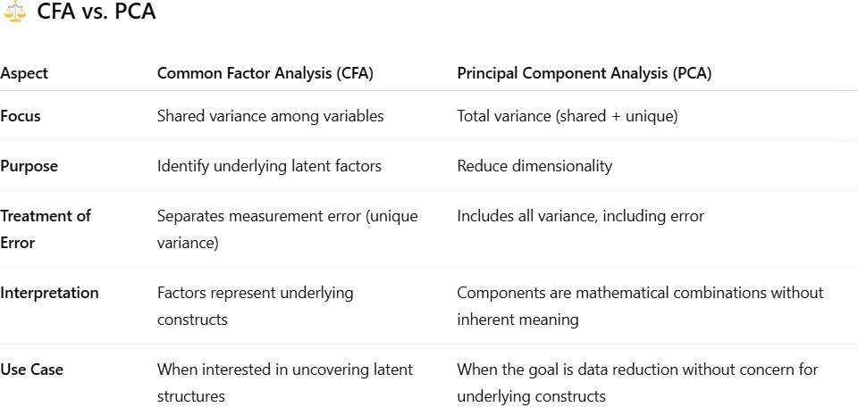

Assumptions of Factor Analysis
Factor analysis works based on a few important rules or assumptions:
  - Linearity: It assumes that the relationships between variables are straight-line (linear).
  - No Multicollinearity: The variables shouldn’t be too similar or strongly related to each other in a way that causes problems.
  - Relevant variables: The analysis should include only the variables that matter to the topic or question.
  - Real connections: There should be real and meaningful relationships between the variables and the factors we are trying to identify.
  - Adequate Sample Size: Factor analysis requires a sufficient sample size to produce reliable results. The required size depends on the complexity of the model and the ratio of variables to cases.
  - Homoscedasticity: The variance of variables should be approximately equal across different levels of the factors.
  - Uniqueness: Each variable should have unique variance that is not explained by the factors. This is especially important in common factor analysis.
  - Independent Observations: The observations in the dataset should be independent of each other.
  - Linearity of Factor Scores: The relationship between observed variables and latent factors is assumed to be linear.
  - Interval or Ratio Scale: Variables should be measured on interval or ratio scales rather than nominal or ordinal scales.

Independent Component Analysis(ICA)
Independent Component Analysis (ICA) is a statistical and machine learning technique used to separate a complex signal into independent components.
A signal means data that contains information, often a mixture of different sources.

It can be sound, images, sensor data, or any measurements
- In ICA, a signal is usually a mixture of multiple hidden sources Example:
A microphone recording in a room = mix of multiple people talking → this mixed
audio is the signal.
Independent components are the original hidden sources that are mixed together in the signal
Example: In the same room Person A voice and Person B voice are independent components
It splits multivariate data into independent and non-Gaussian components. Multivariate data means data with multiple mixed signals
Non-Gaussian components are data components that do not follow a normal (bell-shaped) distribution.
ICA identifies components within mixed signals that are statistically independent of each other.

Statistical Independence Concept:
Statistical independence is a concept in probability theory. Two random variables X and Y are said to be statistically independent if the joint probability distribution is equal to the product of their individual probability distributions.
This means that knowing the outcome of one variable does not change the

probability of the other.
P(X,Y)=P(X)⋅P(Y)
ICA assumes that the original source signals are statistically independent. It tries to separate a mixed signal into these independent components.
The separation is successful when the extracted components satisfy the independence condition.

Example
Imagine you are in a room where two people are speaking at the same time and there are two microphones placed in different positions.
- Each microphone records a mixed signal (both voices combined).
- The original voices of Person A and Person B are the independent source signals.

ICA works like this:
- It takes the mixed recordings from the microphones
- Then separates them into individual voices

Result:
- Voice of Person A (independent component)
- Voice of Person B (independent component)

Assumptions of ICA:
- The first assumption states that the source signals (original signals) are statistically independent of each other.
- The second assumption is that each source signal follows a non-Gaussian distribution.

Advantages of Independent Component Analysis (ICA):
  - ICA is a powerful technique used to separate mixed signals into independent components, useful in areas like signal processing, image analysis, and data compression.
  - ICA is a non-parametric method, meaning it does not require assumptions about the data’s probability distribution.

  - ICA is an unsupervised learning technique, so it does not need labeled data and can be applied directly to raw data.
  - ICA can be used for feature extraction, helping to identify important features for tasks like classification.

Disadvantages of Independent Component Analysis (ICA):
- ICA assumes that the source signals are non-Gaussian, which may not always be true. If the sources are Gaussian, ICA may not work effectively.
- ICA assumes that the signals are linearly mixed. If the mixing is nonlinear, ICA may fail to separate the sources properly.
- ICA can be computationally expensive, especially for large datasets, making it difficult to use in real-world applications.
- ICA may face convergence issues, meaning it may not always find a proper solution, particularly for complex data with many sources

Cocktail Party Problem:
Imagine you are at a noisy party where many people are talking at the same time. However, you can still focus on and listen to one specific person, such as your friend.
This ability to separate one sound source from a mixture of many is known as the Cocktail Party Problem. In machine learning and signal processing, it refers to Separating individual signals from a mixture of multiple overlapping signals (usually audio).
The Cocktail Party Problem is also called the Blind Source Separation problem, which is solved using Independent Component Analysis (ICA).
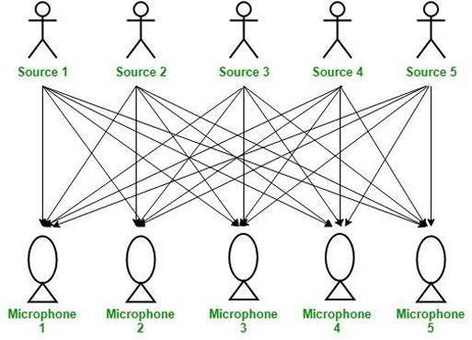

Problem:
To extract independent source signals from a mixed signal composed of multiple sources.

Given:
A mixed signal from five different independent sources.

Aim:
To decompose the mixed signal into independent sources:
- Source 1
- Source 2
- Source 3
- Source 4
- Source 5

Solution:
Independent Component Analysis (ICA)
In this scenario, a party is taking place in a room full of people. There are ‘n’ speakers in the room, and they are speaking simultaneously.
In the same room, there are also ‘n’ microphones placed at different distances from the speakers, which record the voices of all the speakers.
Thus, the number of speakers is equal to the number of microphones in the room.
Now, using the recordings from these microphones, we aim to separate the voice signals of all the ‘n’ speakers in the room.
Each microphone records a mixed signal, where the voice of each speaker is captured with different intensities due to varying distances.
Decomposing these mixed signals into individual independent speech signals can be achieved using the machine learning technique Independent Component Analysis (ICA).

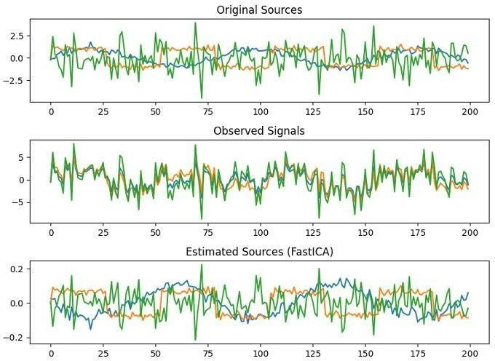

Locally Linear Embedding (LLE)
LE (Locally Linear Embedding) is an unsupervised machine learning method used to reduce the number of dimensions in data. It takes data from a high-dimensional space and changes it into a lower-dimensional form. While doing this, it tries to keep the important shape and structure of the data, especially when the data has a complex, curved (non-linear) pattern.

LLE operates in several key steps:
- First, it finds the closest neighbors for each data point to understand which points are similar. Then, it finds the best way to combine these neighbors to recreate the original point with as little error as possible. The results(weights) are stored in a matrix that shows how strongly each point is connected to its neighbors.
- Next, LLE finds eigenvectors from a matrix made using the weights. These eigenvectors help create a simpler version of the data with fewer dimensions.

Mathematical Implementation of LLE Algorithm:
The main idea of LLE is that around each data point, the nearby points form a simple, locally linear (flat) structure. LLE attempts to unfold or unroll the data while preserving these local linear relationships.
Unfolding means converting curved data into flat form without changing nearby relationships
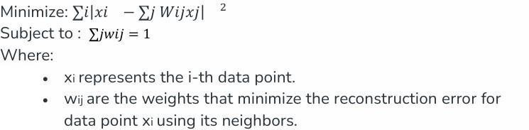
It aims to find a lower-dimensional representation of data while preserving local relationships.

LLE uses a mathematical formula to reduce error when rebuilding each point using its k nearest neighbors. It finds the best weights for the neighbors, and these weights must add up to 1.
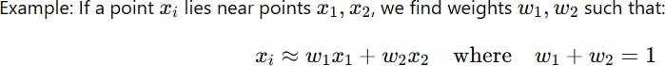

Locally Linear Embedding (LLE) is a dimensionality reduction technique used in machine learning and data analysis. It focuses on preserving local relationships between data points when mapping high- dimensional data to a lower-dimensional space.

Locally Linear Embedding Algorithm
The LLE algorithm can be broken down into the following steps:
- Neighborhood Selection: For every point in the high-dimensional space, LLE finds its closest k neighbors. This is important because LLE believes each data point can be closely represented by a simple combination of these neighbors.
  - Weight Matrix Construction: LLE computes a set of weights for each data point to express it as a linear combination of its neighbors. These weights are determined in such a way that the reconstruction error is minimized. Linear regression is often used to find these weights. Reconstruction error means the difference between the original data point and the data point recreated using its neighbors.
  - Global Structure Preservation: After finding the weights, LLE tries to create a simpler version of the data in fewer dimensions. It looks for new data points that keep the local relationships between neighbors the same. To do this, it uses a formula that measures how well each new data point can be built from its neighbors, and tries to make this as good as possible.
- Output Embedding: Once the optimization process is complete, LLE provides the final lower-dimensional representation of the data. This new version keeps the important structure of the original data.

Parameters in LLE Algorithm:
LLE has a few parameters that influence its behavior:
- k (Number of Neighbors): This parameter determines how many nearest neighbors are considered when constructing the weight matrix. A larger k captures more global relationships but may introduce noise. A smaller k focuses on local relationships but can be sensitive to outliers. Selecting an appropriate value for k is essential for the algorithm’s success.
- Dimensionality of Output Space: You can decide how many dimensions to reduce the data to. Choosing fewer dimensions makes the data easier to handle but may result in loss of some information. On the other hand, choosing more dimensions preserves more information but makes the data more complex and slower to process.
- Distance Metric: LLE uses a distance metric to measure how close two points are
  - This helps it find the nearest neighbors for each point.
  - Different ways of measuring distance can give different neighbors, which affects the final result.
Common Distance Types:
- Euclidean Distance: The straight-line distance between two points (like using a ruler).
- Manhattan Distance: The distance if you can only move in straight lines along a grid (like walking in city blocks).
- Custom Distance: A special way of measuring distance based on your data.
- Regularization (Optional): Sometimes, LLE can overfit, especially when:
  - The data has a lot of noise (random errors or unwanted variations), or
  - You use a large number of neighbors (k).
To avoid this, a regularization term is added to the cost function.
Regularization helps the model stay simple and stable, so it doesn't try to fit

every tiny detail (which might be just noise).
- OptimizationAlgorithm(Optional): LLE often uses optimization techniques like Singular Value Decomposition (SVD) or eigenvector methods to find the lower-dimensional representation. These optimization methods may have their own parameters that can affect the result.

Advantages of LLE
The following are advantages of LLE
- Preservation of Local Structures: LLE is very good at keeping the original shape of the data in small local areas. It works well when the data lies on a curved or complex surface (called a nonlinear manifold).LLE keeps the distances between nearby points almost the same, even after reducing the number of dimensions.
- Handling Non-Linearity: LLE has the ability to capture nonlinear patterns and structures in the data, in contrast to linear techniques like Principal Component Analysis (PCA). When working with complicated, curved, or twisted datasets, it is especially helpful.
- Dimensionality Reduction: LLE reduces the number of features (dimensions) in the data but keeps its important structure.This makes it easier to see, understand, and analyze the data — especially when the original data has many dimensions..

Disadvantages of LLE
The following are the disadvantages of LLE
- Curse of Dimensionality: LLE can suffer from the curse of dimensionality when applied to very high-dimensional data. As the number of dimensions increases, more neighbors are needed to capture local relationships, which can increase the computational cost of the method.
- Memory and computational Requirements: For large datasets, building a weighted adjacency matrix in LLE can require a lot of memory. Also, the eigenvalues decomposition step can be computationally expensive and slow for big datasets.
- Outliers and Noisy data: LLE is sensitive to noisy data and outliers. The quality

of the embedding may be affected, and the local relationships between data points can get distorted due to these outliers.

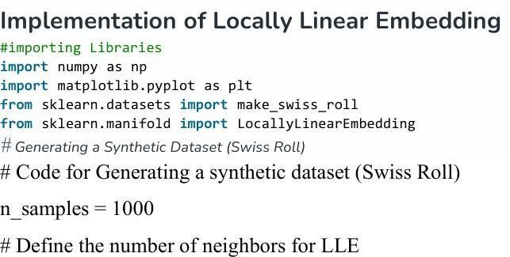

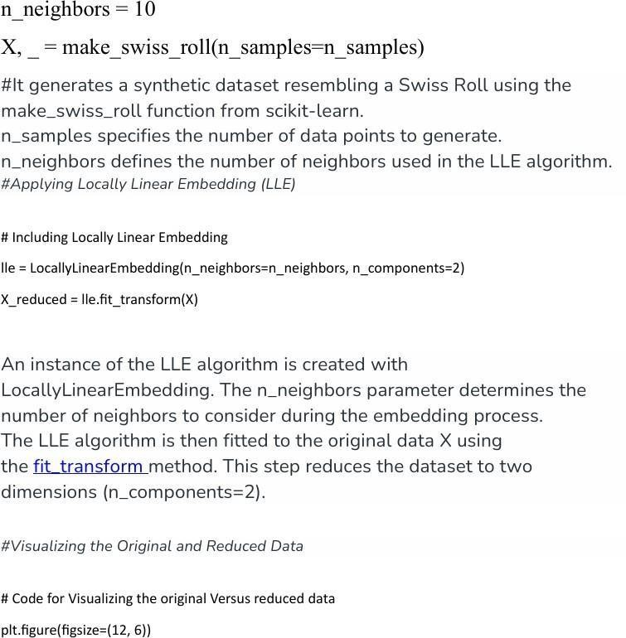

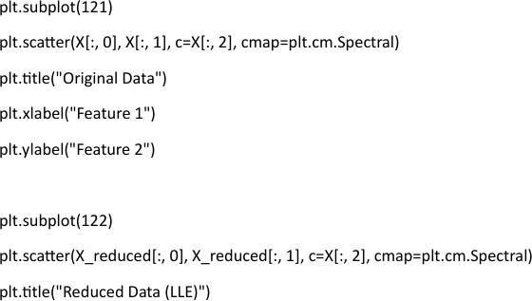

ISOMAP
Isomap, short for Isometric Mapping, is a nonlinear dimensionality reduction method used in data analysis and machine learning.
Isomap is a smarter way to simplify complex data while preserving its true form, especially when PCA isn’t good enough.
Isomap converts complicated data (with many features/dimensions) into a low-dimensional form (2D or 3D) so we can visualize and understand it easily. But while doing this, Isomap makes sure to keep the true distances between points — meaning, if two things were close or far apart in the original data, they will still be close or far apart on the new map.

Isomap is very useful when we have big and complicated data, like:
Voice recordings (speech recognition) Photos and pictures (image analysis)
Data from the human body (like genes, cells, etc.)
Even though this kind of data has many details and is hard to understand, Isomap helps by pulling out the hidden structure — the important patterns inside the data.
In machine learning, it's very important to understand and represent complicated data clearly.
One of the best techniques in manifold learning is ISOMAP. Manifold Learning is a part of unsupervised learning.
It's better than simple linear methods (like PCA) when the data lies on a curved or complex surface.

Relation between Geodesic Distances and Euclidean Distances
To understand ISOMAP better, it’s important to know the difference between two types of distances:

- Euclidean distance – This is the usual straight-line distance between two points (like drawing a line on a flat paper).
- Geodesic distance –This is the shortest path along a curved surface, like walking along a hill or the surface of a globe
  - ISOMAP uses geodesic distances because many real-life data sets lie on curved surfaces (called manifolds).
  - If we only use straight-line (Euclidean) distances, we might miss the true relationships between data points.
  - By using geodesic distances, ISOMAP gives a more accurate picture of how the data is shaped inside.
  - ISOMAP takes advantage of these curved distances to better uncover the
hidden structure of complex data.
  - ISOMAP uses this shortest path (Geodesic distance) to preserve true relationships between data points.

ISOMAP Parameters
ISOMAP comes with several parameters, each influencing the dimensionality reduction process:
- n_neighbors: Isomap needs to decide how many nearby points (neighbors) to consider when calculating distances..
  - If you choose more neighbors, you might get better and smoother results.
  - But using more neighbors also means it needs more computer power and time to calculate.
- N_components: Determines the number of dimensions in a low dimensional representation.

eigen_solver: It decides how to calculate eigenvalues and eigenvectors
There are options such as "auto", "arpack" and "dense." Auto: System automatically chooses the best method Arpack: Used for large datasets (faster, efficient)
Dense: Used for small datasets (more accurate, but slower)

- Radius: Instead of choosing a fixed number of neighbors, you can set a distance (a radius) around each point.
  - Only the points within that radius are counted as neighbors.
  - Any points outside the radius are ignored — they are not treated as neighbors.
- Tolerance: When ISOMAP solves part of the math using an eigenvalues-solver, it uses something called tolerance to decide when to stop the calculations.
  - Lower tolerance = more accuracy, but slower.
  - Higher tolerance = faster, but maybe less accurate.
- max_iter: This setting controls the maximum number of times the eigenvalue solver is allowed to run.
  - If you set a number, it will stop after that many tries, even if it hasn’t finished perfectly.
  - If you don’t set a number, it will keep running until it either finds the solution or some other stop rule is met.
- path_method: This setting decides how ISOMAP calculates the curved (geodesic) distances between points on the graph.
You can choose:
  - ‘auto’ – ISOMAP will automatically pick the best method.
  - ‘FW’ (Floyd-Warshall) – A specific method that finds shortest paths between all points.
- neighbors_algorithm: This setting decides how ISOMAP finds the nearest neighbors (the closest points).
You can choose from:
  - ‘auto’ – ISOMAP will automatically pick the best method based on your data.
  - ‘ball_tree’ – Good for handling large and spread-out data.

  - ‘kd_tree’ – Works well when data has fewer features.
  - ‘brute’ – Checks all points one by one (slow, but simple and accurate).
You choose how to search for nearest neighbors. If you’re not sure, ‘auto’ is the safest choice.
- Metric: This setting tells ISOMAP how to measure the distance between points when finding nearest neighbors.
There are different ways to do this:
  - ‘Minkowski’ – The default method that can behave like other distance types depending on settings.
  - ‘Euclidean’ – Measures the straight-line distance (like a ruler).
  - ‘Manhattan’ – Measures distance like moving along city blocks (only up/down and left/right).
There are other distance types too, depending on your data.

Working of Isomap
- Calculate pairwise distances: The algorithm starts by calculating the
Euclidean distances between all data points.
- Find nearest neighbors: For each data point, its k nearest neighbors are determined based on these distances.
- Create a neighborhood graph: Isomap connects nearby points with edges to represent the local structure of the data.
- Calculate geodesic distances: Using algorithms like Floyd’s algorithm (or Dijkstra), it finds the shortest path between all points in the graph to compute geodesic distances.
- Perform dimensionality reduction: MDS (Multidimensional Scaling) uses these distances to create a low-dimensional (2D/3D) representation of the data.

Advantages and Disadvantages of Isomap Advantages
Captures non-linear relationships: Unlike linear methods such as Principal Component Analysis, Isomap can capture the underlying non-linear structure of data.
Preserves global structure: It maintains the overall relationships between data points, giving a better representation of the entire manifold.
Globally optimized: It finds the best low-dimensional representation based on distances in the graph.

Disadvantages
High computational cost: For large datasets, computing geodesic distances (using algorithms like Floyd’s) is time-consuming.
Sensitive to parameters: Incorrect choice of parameters (like number of neighbors
k) can lead to distorted or misleading results.
Difficulty with complex manifolds: If the data manifold has holes or complex topology, Isomap may give inaccurate representations.

Applications of Isomap
- Visualization: High-dimensional data (like face images) can be converted into 2D or 3D, making it easier to see and understand.
- Data Exploration: Isomap helps to find patterns and clusters in complex data by showing them in a simple form.
- Anomaly Detection: It helps to identify unusual or different data points (outliers).
- Machine Learning Tasks: Isomap is used as a preprocessing step to improve tasks like classification and clustering by making data easier to understand.

Least Squares Optimization
The Least Square Method is a fundamental mathematical technique used in data analysis, statistics, and regression modeling to find the best-fitting line or curve for a given set of data points.
Least Square Method minimizes the sum of the squares of the errors
(differences between actual and predicted values). By reducing overall error, it

provides a more accurate model for predicting future trends.
In statistics, when you plot data points using two variables — one on the x-axis (independent variable) and one on the y-axis (dependent variable) — it’s called scatter data.
Sometimes, just looking at these points doesn’t help us understand or predict what the y-value will be for a given x-value.
So, we use the Least Squares Method to find the best line that fits through these points.
This line helps us make predictions and understand the relationship between the two variables.

What is the Least Square Method?
The Least Squares Method helps us find a straight-line equation that connects two variables.
First, we plot the known values of the variables as points on a 2D graph (called a scatter plot).

Next, we try to draw a straight line that best fits all these points. We use the Least Squares Method to find the equation of this line.
This equation helps us predict the value of the dependent variable when we know the independent variable but don’t have its matching value yet.

Least Square Method Definition
Least Squares method is a statistical technique used to find the equation of best- fitting curve or line to a set of data points by minimizing the sum of the squared differences between the observed values and the values predicted by the model.
This method aims at minimizing the sum of squares of deviations as much as possible. The line obtained from such a method is called a regression line or line of best fit.

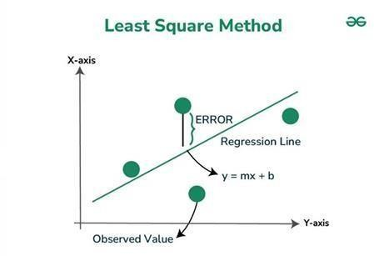

Formula for Least Square Method

The Least Squares Method is used to find the best-fitting line for a set of data points.
In simple linear regression, the line is written as: y = mx + c Where:
- y → dependent variable (output)
- x → independent variable (input)
- m → slope of the line
- c → y-intercept (value of y when x = 0)

It finds the best straight line that is closest to all data points.
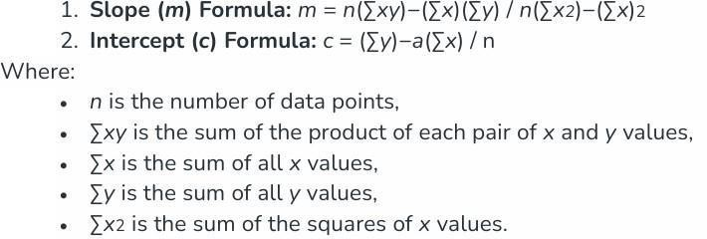

Steps to Find Line of Best Fit
Step 1: Denote the independent variable as xᵢ and the dependent variable as yᵢ.
Step 2: Calculate the average (mean) values:

X̄ = mean of x values Ȳ = mean of y values
Step 3: Assume the equation of the best-fit line:
y = mx + c where m is slope and c is intercept.
Step 4: Calculate the slope m using the formula:

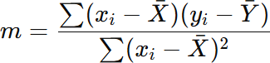

Step 5: Calculate the intercept c using the formula:

c = Ȳ − mX̄
Step 6: After finding m and c, the line of best fit is:

y = mx + c
It minimizes the sum of squared differences between actual and predicted values which provides an accurate model for prediction

Least Square Method Graph
Let us look at how the data points and the line of best fit are obtained.
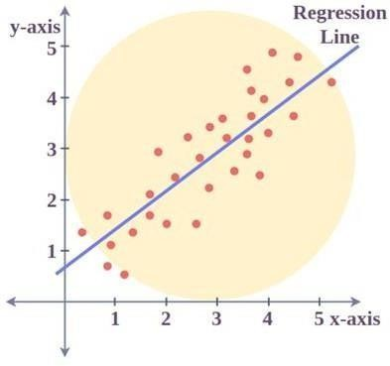

- The red points in the graph represent the given data points.
- The independent variable (x) is plotted on the x-axis, and the dependent variable (y) is plotted on the y-axis.
- The blue line represents the line of best fit obtained using the Least Squares Method.

Limitation of the Least Square Method
Least Squares gives good results only if the data is regular and clean — not if it’s messy or has outliers.

Least Square Method Solved Example
Problem1: Find the line of best fit for the data points using the Least Squares Method:
(x,y) = (1,3), (2,4), (4,8), (6,10), (8,15).
Solution:
Step 1: Write the values
x | Y
1 | 3
2 | 4
4 | 8
6 | 10
8 | 15
Step 2: Calculate means
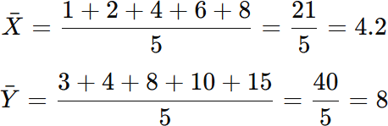

Step 3: Calculate slope (m)

Create table:

x | y | x-4.2 | y-8 | (x-4.2)(y-8) | (x-4.2)²
1 | 3 | -3.2 | -5 | 16 | 10.24
2 | 4 | -2.2 | -4 | 8.8 | 4.84
4 | 8 | -0.2 | 0 | 0 | 0.04
6 | 10 | 1.8 | 2 | 3.6 | 3.24
8 | 15 | 3.8 | 7 | 26.6 | 14.44
Sum:

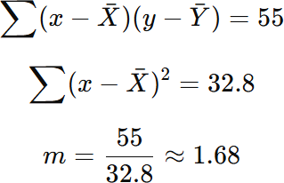

Step 4: Calculate intercept (c)

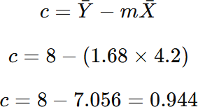

The line y = 1.68x + 0.94 is the best-fit line, which can be used to predict values of y for given

Evolutionary Learning
Evolutionary learning is a way of solving problems by mimicking the process of evolution in nature. It’s inspired by the way species adapt and improve over generations.
Here’s how it works:
- Starting with a group – We begin with multiple possible solutions to a problem.
- Evaluating them – We test each solution to see how well it works.
- Selecting the best – The best-performing solutions are chosen.
- Modifying and combining – The selected solutions are slightly changed (mutated) or combined (like DNA mixing in reproduction).
- Repeating the process – The cycle continues, improving solutions step by step, just like nature evolves species over time.
This method is used in AI, optimization problems, and even robotics to find the best possible solutions to complex challenges. It’s like letting nature do the thinking.

Genetic Algorithms
Genetic Algorithms (GAs) are smart problem-solving methods that use ideas from nature, like how living things evolve over time. They belong to a group called evolutionary algorithms.
GAs work by copying the process of natural selection— where the best solutions are kept and weaker ones are removed. Over time, the solutions get better and better.
They use random guesses, but in a smart way. GAs also learns from past results to focus on areas where good solutions are more likely to be found.
These algorithms are often used to solve tough problems where we need to find the best or most efficient answer, like in optimization and searching.
Genetic Algorithms are methods that copy the way nature works to solve problems.

They work like natural selection – which means that the solutions that can adjust and perform better are kept, and the weaker ones are removed.
In simple words, they follow the idea of "survival of the fittest" – the best solutions survive and are used to create better ones in the next round.
Each round (called a generation) has a group of possible solutions (called a

population).
Each solution is like a point in a big search area, and it might be the answer to the problem.
Each solution is shown as a string made up of characters, numbers, or bits (like 0s and 1s).
This string acts like a chromosome (just like in real biology).

Foundation of Genetic Algorithms
Genetic Algorithms work like how real-life genetics and evolution happen in nature. They are based on how chromosomes behave in a population. Here’s how they work:
- Each solution (individual) in the group tries to survive and grow. Just like in nature, they compete to get the best results.
- The best solutions (the fittest) get a chance to mix and create new solutions. These are like parents creating children.
- The children (new solutions) get genes from the better parents. Sometimes, the children are even better than both parents.
- With each new round (generation), the solutions get better.
Over time, the group becomes more suitable for solving the problem.

Search space
In Genetic Algorithms, a group of possible solutions (called a population) is kept and explored within a certain area called the search space (the set of all possible answers to the problem).
Each individual in this group is one possible solution to the problem.
We write each individual as a fixed-length list (like a row of values). This list is like a chromosome in biology.

Each value in the list is called a gene, and it represents one part of the solution. So, a chromosome (solution) is made up of many genes (parts of that solution). Example:
If we are solving a problem using 5 numbers, a solution (individual) might look like this:
[3, 5, 2, 8, 1]
- This whole list is the chromosome.
- Each number (3, 5, 2, etc.) is a gene.
Together, they represent one possible answer to the problem.

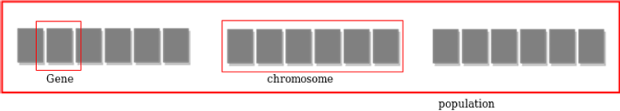

Fitness Score
A fitness score is given to each solution (individual) to show how good it is at solving the problem. The better the score, the better the solution.
The Genetic Algorithm keeps a group of solutions (called a population). Each solution has its own fitness score.
Solutions with higher fitness scores are more likely to be chosen to create the next generation.
(Just like in nature, the stronger or more successful individuals are more likely to reproduce.)
These selected solutions combine (mate) to create new solutions (children) by mixing parts of their "genes."
Since the number of solutions in the group stays the same, some old or weaker solutions are removed to make space for the new ones.

Over time, this process creates new generations.
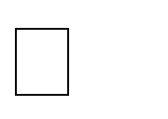
Each generation usually has more good parts (genes) than the one before Good solutions survive and make better ones.
Bad solutions are removed.
over time, the population improves.
When no more big improvements happen, the algorithm is done.

Genetic Offspring
In Genetic Algorithms, offspring are the new solutions created by combining two existing solutions (called parents).
Just like in nature, where parents have children (offspring) who inherit traits from both parents,
in Genetic Algorithms:
- Two good solutions (parents) are selected.
- They are mixed together using a method called crossover.
- This creates a new solution (offspring) that contains parts from both parents.
Sometimes, a small random change (mutation) is added to the offspring to introduce new traits.
Why Offspring Are Important:
- Offspring carry the best traits from their parents.
- They help the population improve over time.
- The goal is to create even better solutions in the next generation.

Example:
- Parent 1: [3, 5, 2, 9]
- Parent 2: [1, 8, 7, 4]
- Offspring: [3, 5, 7, 4] (mixing the first half of Parent 1 and second half
of Parent 2)

Genetic Operators
After creating the first group of solutions, the algorithm improves them using the following operators

Selection Operator
It means choosing the best solutions (those with high fitness scores) and letting them pass their good parts (genes) to the next generation.

Crossover Operator
This step is like reproducing between two solutions. Two solutions are picked using the selection step.
Then, a random point is chosen, and their genes (parts of the solution) are swapped at that point.
This creates a new solution (called offspring) that has features from both parents. Example –
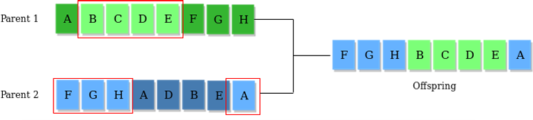

Mutation Operator:
The main idea is to randomly change some parts (genes) of a solution to keep the population diverse. This helps prevent the algorithm from getting stuck too early with the wrong or average answers.
For example –

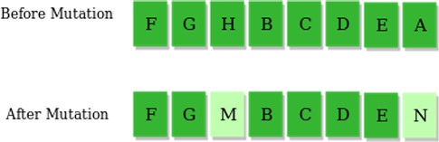

The whole algorithm can be summarized as–
- Create a random group of solutions (called population p).
- Check how good each solution is (this is called fitness).
- Repeat these steps until a good enough solution is found:
  - Pick the best solutions to be parents.
  - Mix the parents to make a new group of solutions (crossover).
  - Make small random changes to some solutions (mutation).
  - Check how good the new solutions are (calculate fitness).
This process continues until the algorithm finds a solution that is good enough.

Using Genetic Algorithms

Advantages of Genetic Algorithms
- They are strong and reliable (robust).
- They can search and find good solutions in a large area of possible answers.
- Unlike traditional AI methods, they still work well even if the input changes a little or if there is noise (unwanted data).

Applications of Genetic Algorithms:
Genetic Algorithms are used in many areas, such as:
- Recurrent Neural Networks (used in deep learning)
- Mutation Testing (for checking software quality)
- Code Breaking (used in security and cryptography)
- Signal Filtering and Processing (used in electronics and communication)
- Learning Fuzzy Rules (used in fuzzy logic systems for decision making)

Recurrent Neural Networks (RNNs)
  - RNNs are a type of neural network used for sequence-based tasks like speech recognition, language translation, and time-series prediction.
  - Genetic Algorithms can be used to:
    - Find the best weights or architecture for the network.
    - Train RNNs without needing gradient-based methods.
  - This is helpful when the error surface is complex or traditional methods like backpropagation don’t work well.

Mutation Testing
  - Mutation testing is used to check the quality of software tests.
  - In this, small changes (mutations) are made to the original program code to see if the tests can detect the errors.
  - Genetic Algorithms can be used to:

Automatically generate mutated versions of programs.
    - Select effective test cases that can catch more bugs.
  - This helps in improving the reliability of software.

Code Breaking (Cryptanalysis)
  - Code breaking means trying to find the key or method used to encrypt data.
  - GAs can:
    - Try out different possible keys or rules.
    - Use fitness to measure how close they are to the correct message.
  - This is useful in security testing and cryptography research.

Filtering and Signal Processing
  - Signal processing is used in audio, video, and sensor data to clean or interpret signals.
  - GAs can:
    - Design filters that best remove noise.
    - Optimize signal patterns to improve sound or image quality.
  - They are useful when the signal is complex or noisy, and traditional filter design is hard.

Learning Fuzzy Rule Base
  - Fuzzy logic systems are used for making decisions in uncertain environments (like washing machines, air conditioners, or robots).
  - These systems use if-then rules (fuzzy rules).
  - GAs can help:

Automatically learn and improve these fuzzy rules.
    - Tune the rules to get better results in decision-making.
  - Useful in control systems, pattern recognition, and robotics.

